PERTH MODERN SCHOOL
UNIT 3CD MAS – 2015
TEST 1: SOLUTIONS
POLAR COORDINATES, COMPLEX NUMBERS & VECTORS
NAME: DATE: Feb.
Total: 45 marks Time: 50 min.

Question 1. (5 marks)
(i) Point P has polar coordinates (4,17  ) and it lies on the line 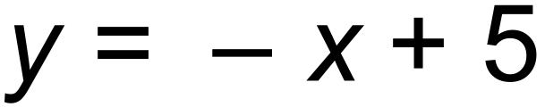
Point Q also lies on the line and is 12cm away from P.

Find the polar coordinates of Q 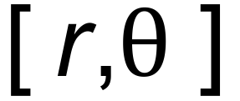 where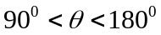. (3 marks)

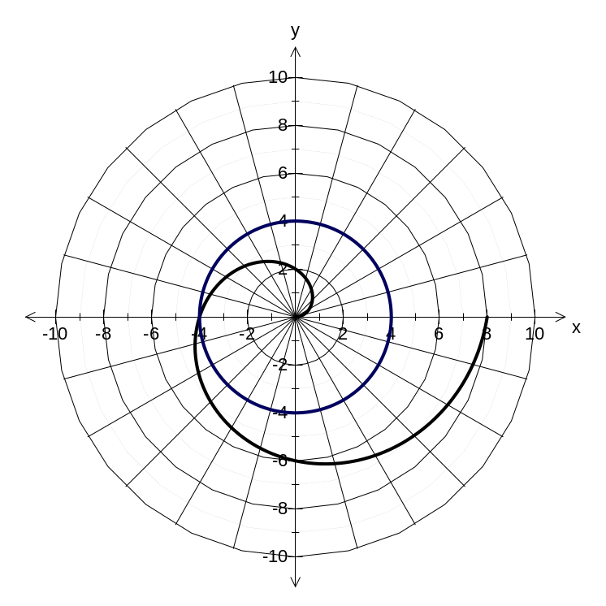
Solution
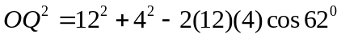
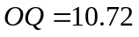
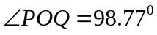
Polar Coordinates of Q = 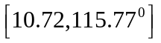
Specific behaviours
✓angle of 62⁰, ✓✓

(ii) Sketch the graph of 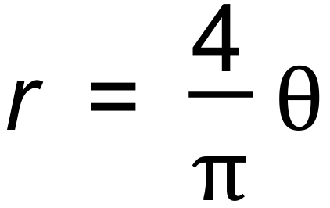 on the axes above and hence state
where it intersects 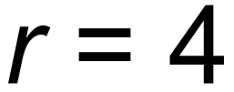 (2 marks)
Question 2 (9 marks)
On a 3D computer game, Chris, a keen cyclist leaves from position 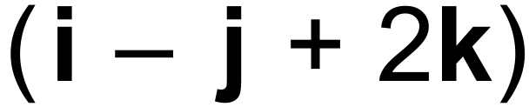 metres is travelling at 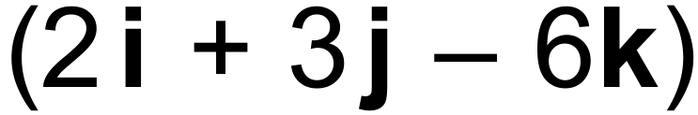 m/s while his mate Dave leaves from position  metres running at m/s.

(i) Although they do not collide, their paths do intersect at the point with coordinates
( a, 1, b).

Determine the values of a and b. (4 marks)

Solution
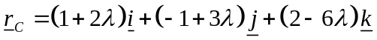
As paths meet at ( a, 1, b ), then ( a, 1, b ) lies on 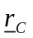
i.e. 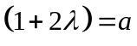 , 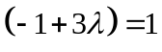 , 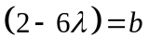✓
Solving these equations simultaneously, 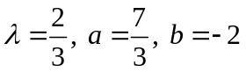✓✓✓
Specific behaviours
As allocated

(ii) Find the acute angle between these two paths. (2 marks)

Solution
Let angle be
✓
= 139.3⁰
Hence acute angle is 40.7⁰✓
Specific behaviours
As allocated

(iii) Hence, determine the perpendicular distance from the point (1,-1,2) to (3 marks)
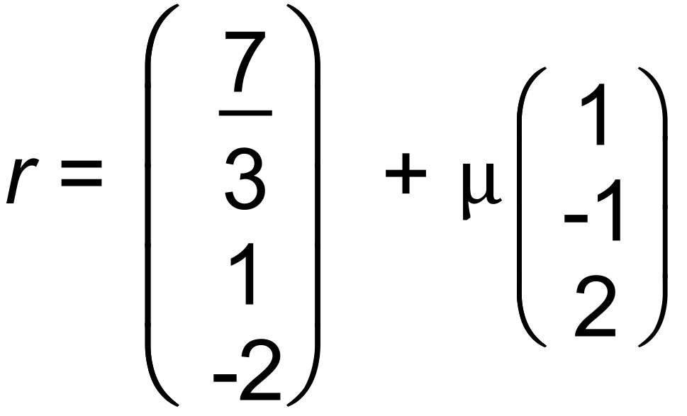

Solution
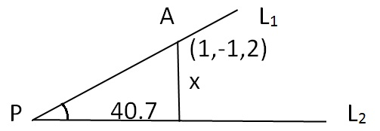
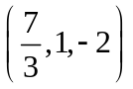
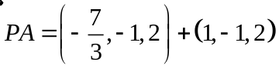
= 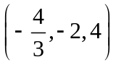✓
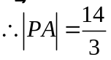✓
Perpendicular distance = 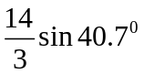 = 3.04 m ✓
Specific behaviours
As allocated

Question 3 (5 marks)
(a) The vectors 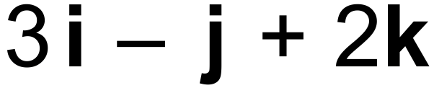 and  are perpendicular. Determine the value of a.
(1marks)

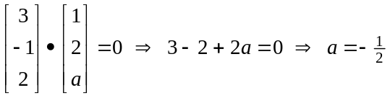

(b) Determine whether the two lines intersect.
If they do intersect, state the position vector of their point of intersection.

If they do not intersect, justify your answer. (4 marks)
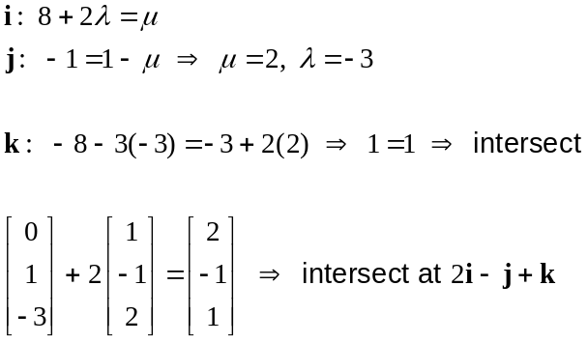
Question 4 (7 marks)
(a) If 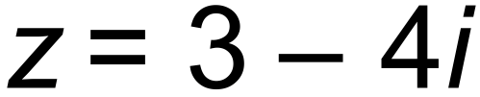 , determine the reciprocal,  (2 marks)

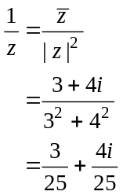

(b) Let the non-zero complex number  . Show that 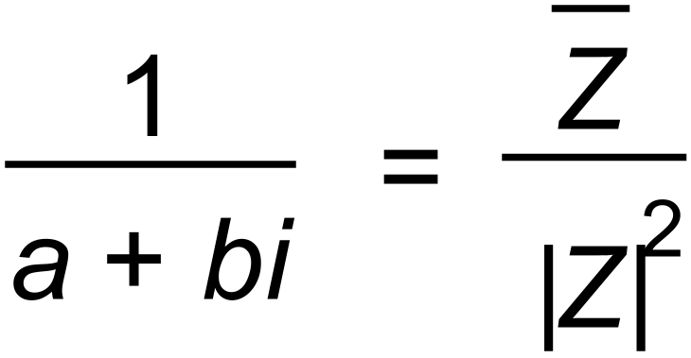 (3 marks)

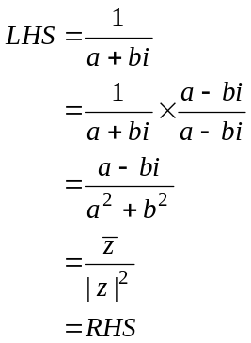

(c) Describe the geometrical relationship between any non-zero complex number
and its reciprocal. (2marks)

The reciprocal 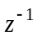 is the conjugate of but multiplied by scale factor of 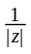.

So the reciprocal will be the reflection of in the real axis and of length times .

Question 5 (5 marks)
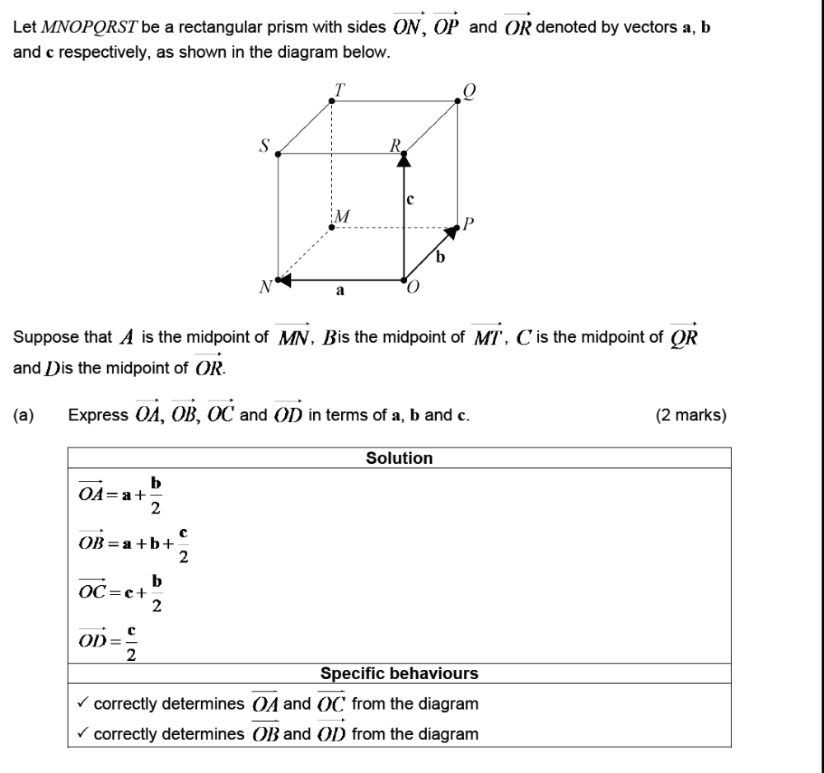
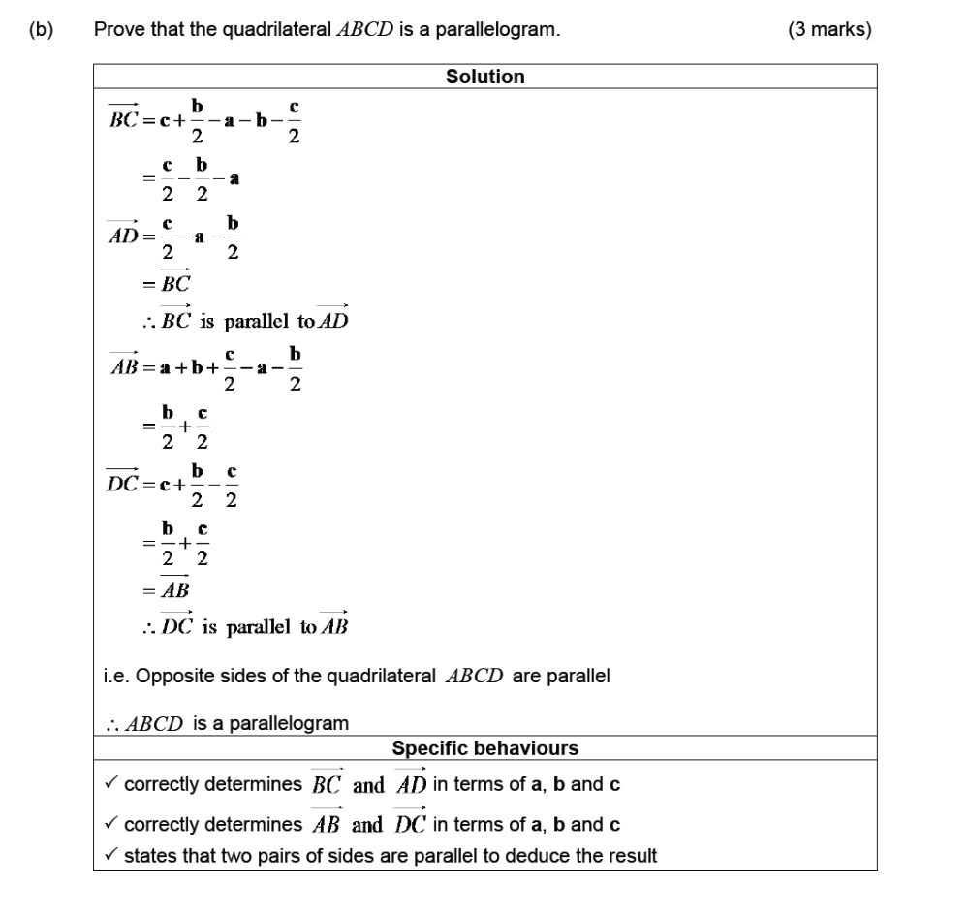

Question 6 (5 marks)
(5 marks)
(a) Change the complex equation 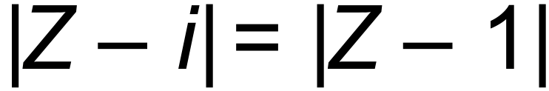 into its Cartesian equivalent. (3 marks)

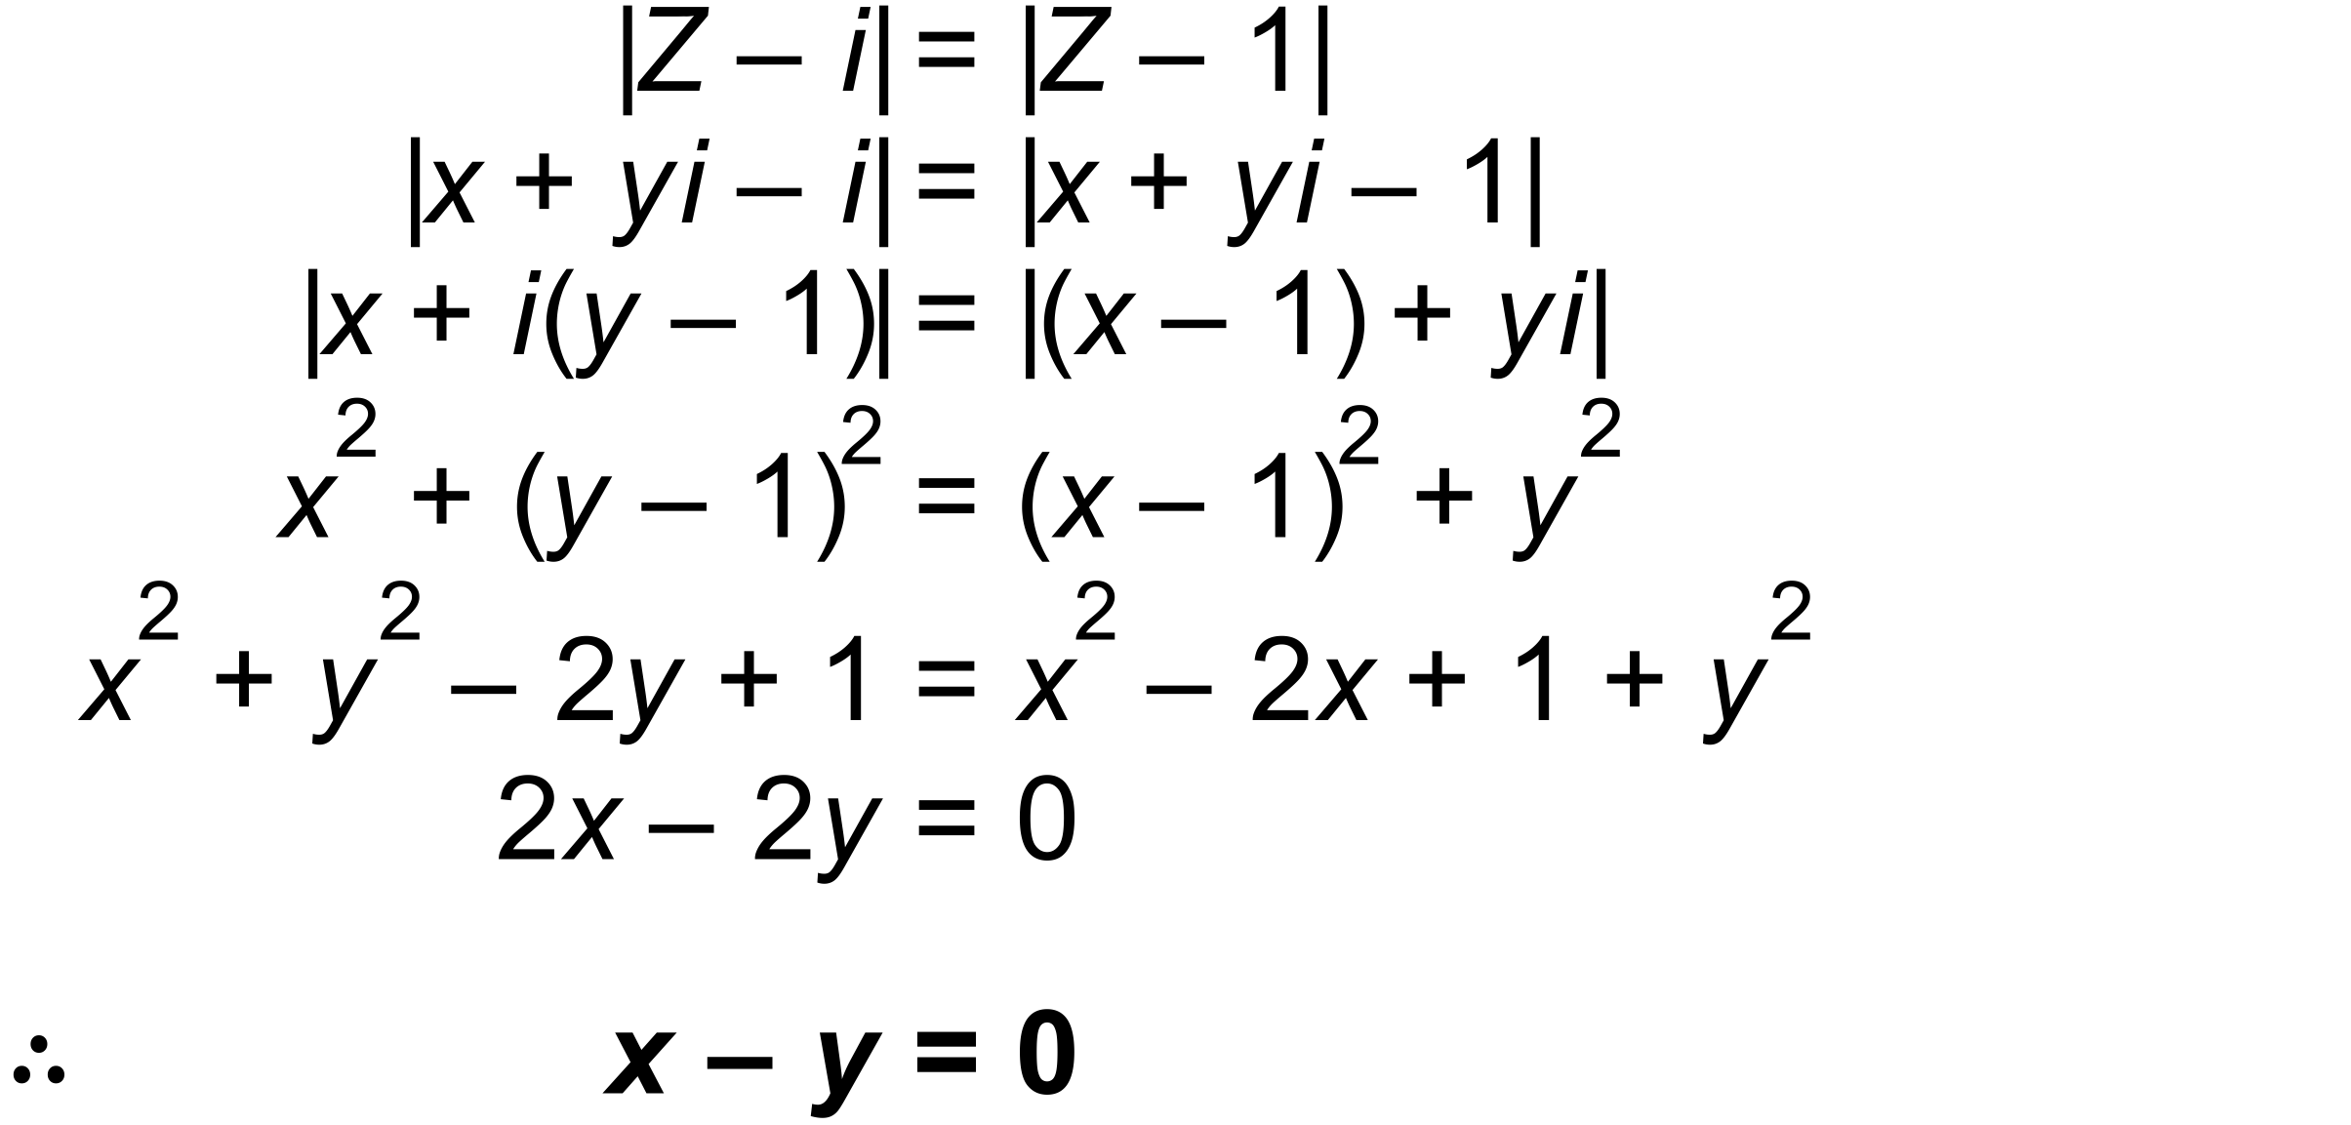

(b) Hence identify, the locus of all points  satisfying the equation in (a). (2 marks)

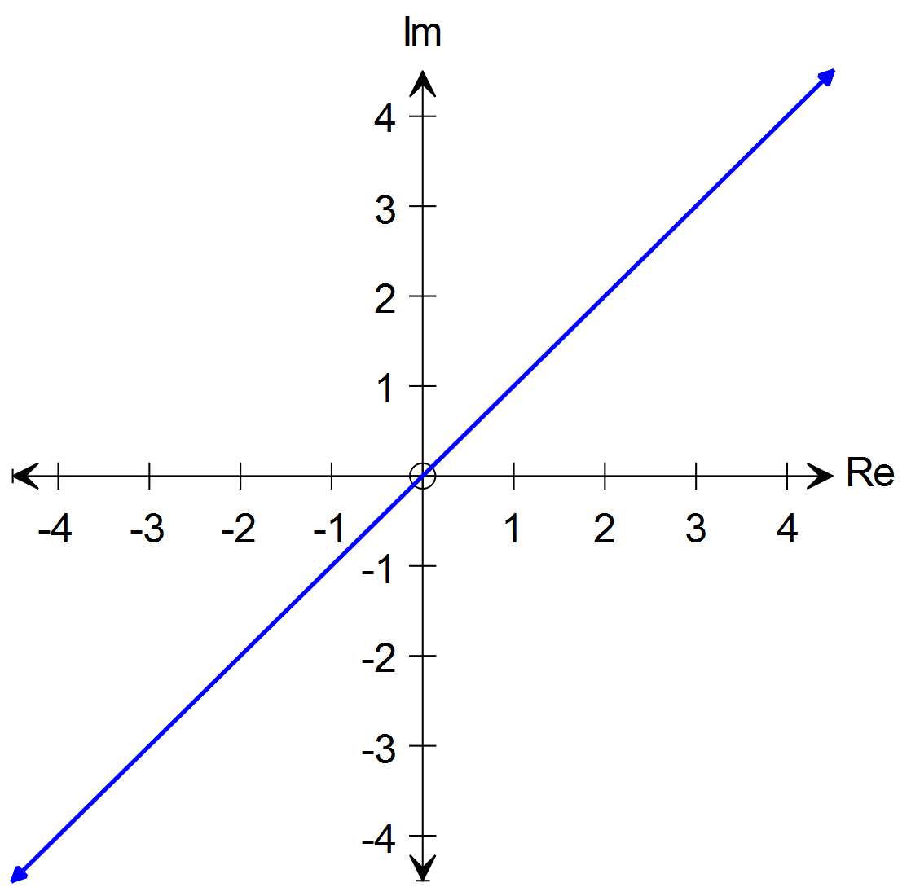

Question 7
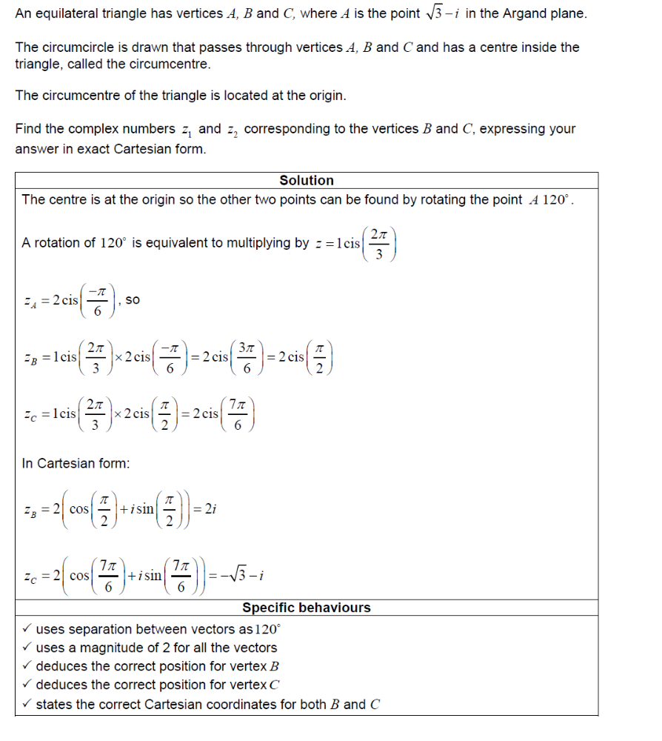
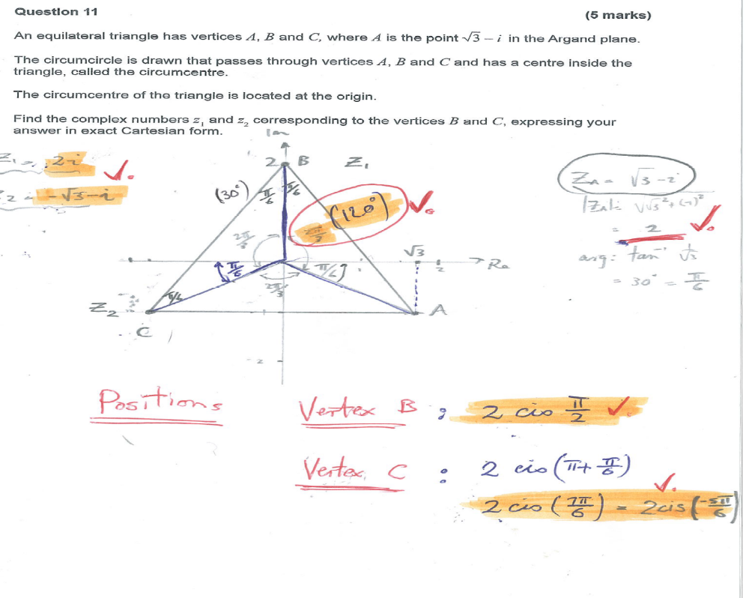

Question 8 (4 marks)
Find two numbers which have a product of 2 and a sum of 2.
Let the numbers be x and y
